***On my honor, I pledge that I have not violated the provisions of the NJIT Student Honor Code***

STUDENT TEAM N**o** __2__

Name Signature

…Arsh Bhamla………… **ARSH BHAMLA~~___~~**_ …Pranay KC………….. _**_PRANAY RAJ KC_____** ..Shreedhar Rajendran. **__Shreedhar Rajendran—**

..Christopher Karkenny. __**Christopher Karkenny**_

Experiment performed on date _02/ 21 / 2025__

Report submitted on date _________

Returned for corrections on date _________ Grade ______

Returned after corrections on date _________ Grade ______

**Introduction**

Counters are very important in digital electronics and can be found in everything from basic timers to complicated systems. In this lab, we will explore how the two main types of counters (asynchronous and synchronous) work. Asynchronous counters where each flip-flop’s clock input is triggered by the previous one, have delays that stack up which slow them down. On the other hand, synchronous counters use one clock signal for all flip-flops which gets rid of the delays and ultimately makes them faster. We will use 74LS76 J-K flip-flops to see the differences in action and figure out what these differences mean in real time. By building and testing these counters we will have a better understanding of how they work in sequential circuits.

**Procedure**

**1.1 Asynchronous Counters**

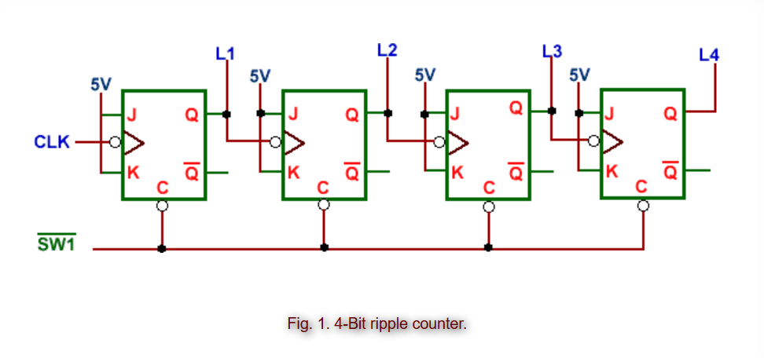

Fig 1. 4-Bit ripple counter shown from [ECE 294 lab manual.](https://ecelabs.njit.edu/ece294/lab4.php)

We will assemble the circuit on a breadboard following figure 1 by connecting the clock pulse generator to the first flip-flop’s clock input and then connect each flip-flop’s output to the next flip-flop’s clock input. We will make sure all flip-flops are powered with 5V. Also, when we apply the clock pulses, we will keep track of the state transitions through LEDs.

**1.2 Synchronous Counters**

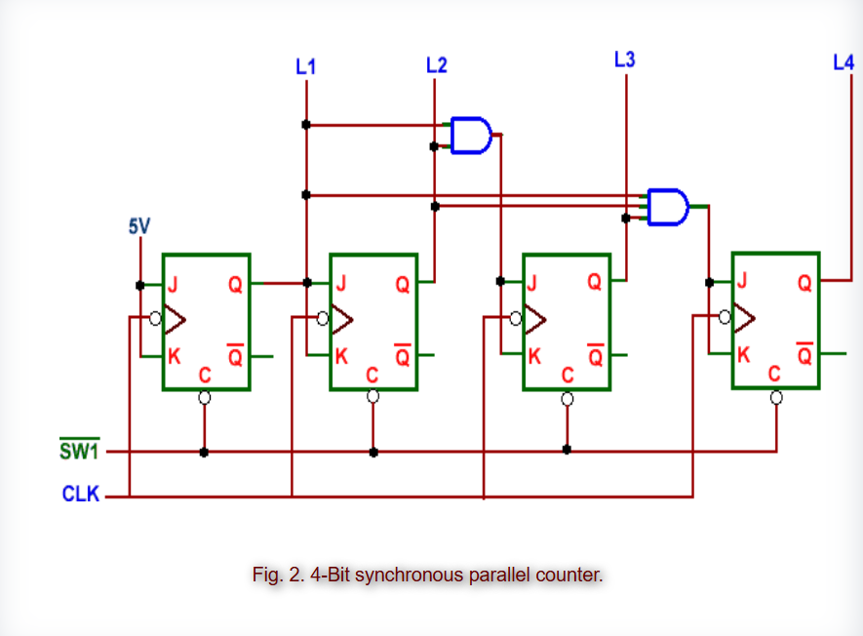

Fig 2. 4-Bit synchronous parallel counter shown from [ECE 294 lab manual.](https://ecelabs.njit.edu/ece294/lab4.php)

We will assemble the circuit on a breadboard following figure 2 by connecting the pulse generator to the clock input of all flip-flops ensuring they share the same clock signal. We will then attach the J and K inputs of each flip-flop to the appropriate logic gates for state control. We will make sure all flip-flops are supplied with a 5V power source and apply clock pulses and observe the synchronous state transitions.

**Data and Calculations**

**1.1 Asynchronous Counters**

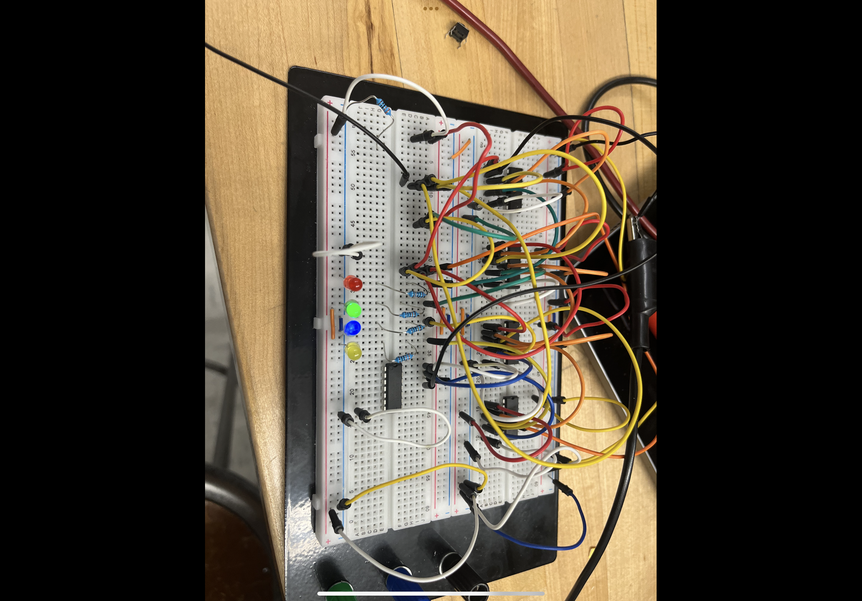

Data Readings

| **Clock** | **LED 1** | **LED 2** | **LED 3** | **LED 4** |
| --- | --- | --- | --- | --- |
| 0 | 0 | 0 | 0 | 0 |
| 1 | 0 | 0 | 0 | 1 |
| 2 | 0 | 0 | 1 | 0 |
| 3 | 0 | 0 | 1 | 1 |
| 4 | 0 | 1 | 0 | 0 |
| 5 | 0 | 1 | 0 | 1 |
| 6 | 0 | 1 | 1 | 0 |
| 7 | 0 | 1 | 1 | 1 |
| 8 | 1 | 0 | 0 | 0 |
| 9 | 1 | 0 | 0 | 1 |
| 10 | 1 | 0 | 1 | 0 |
| 11 | 1 | 0 | 1 | 1 |
| 12 | 1 | 1 | 0 | 0 |
| 13 | 1 | 1 | 0 | 1 |
| 14 | 1 | 1 | 1 | 0 |
| 15 | 1 | 1 | 1 | 1 |

**1.2 Synchronous Counters**

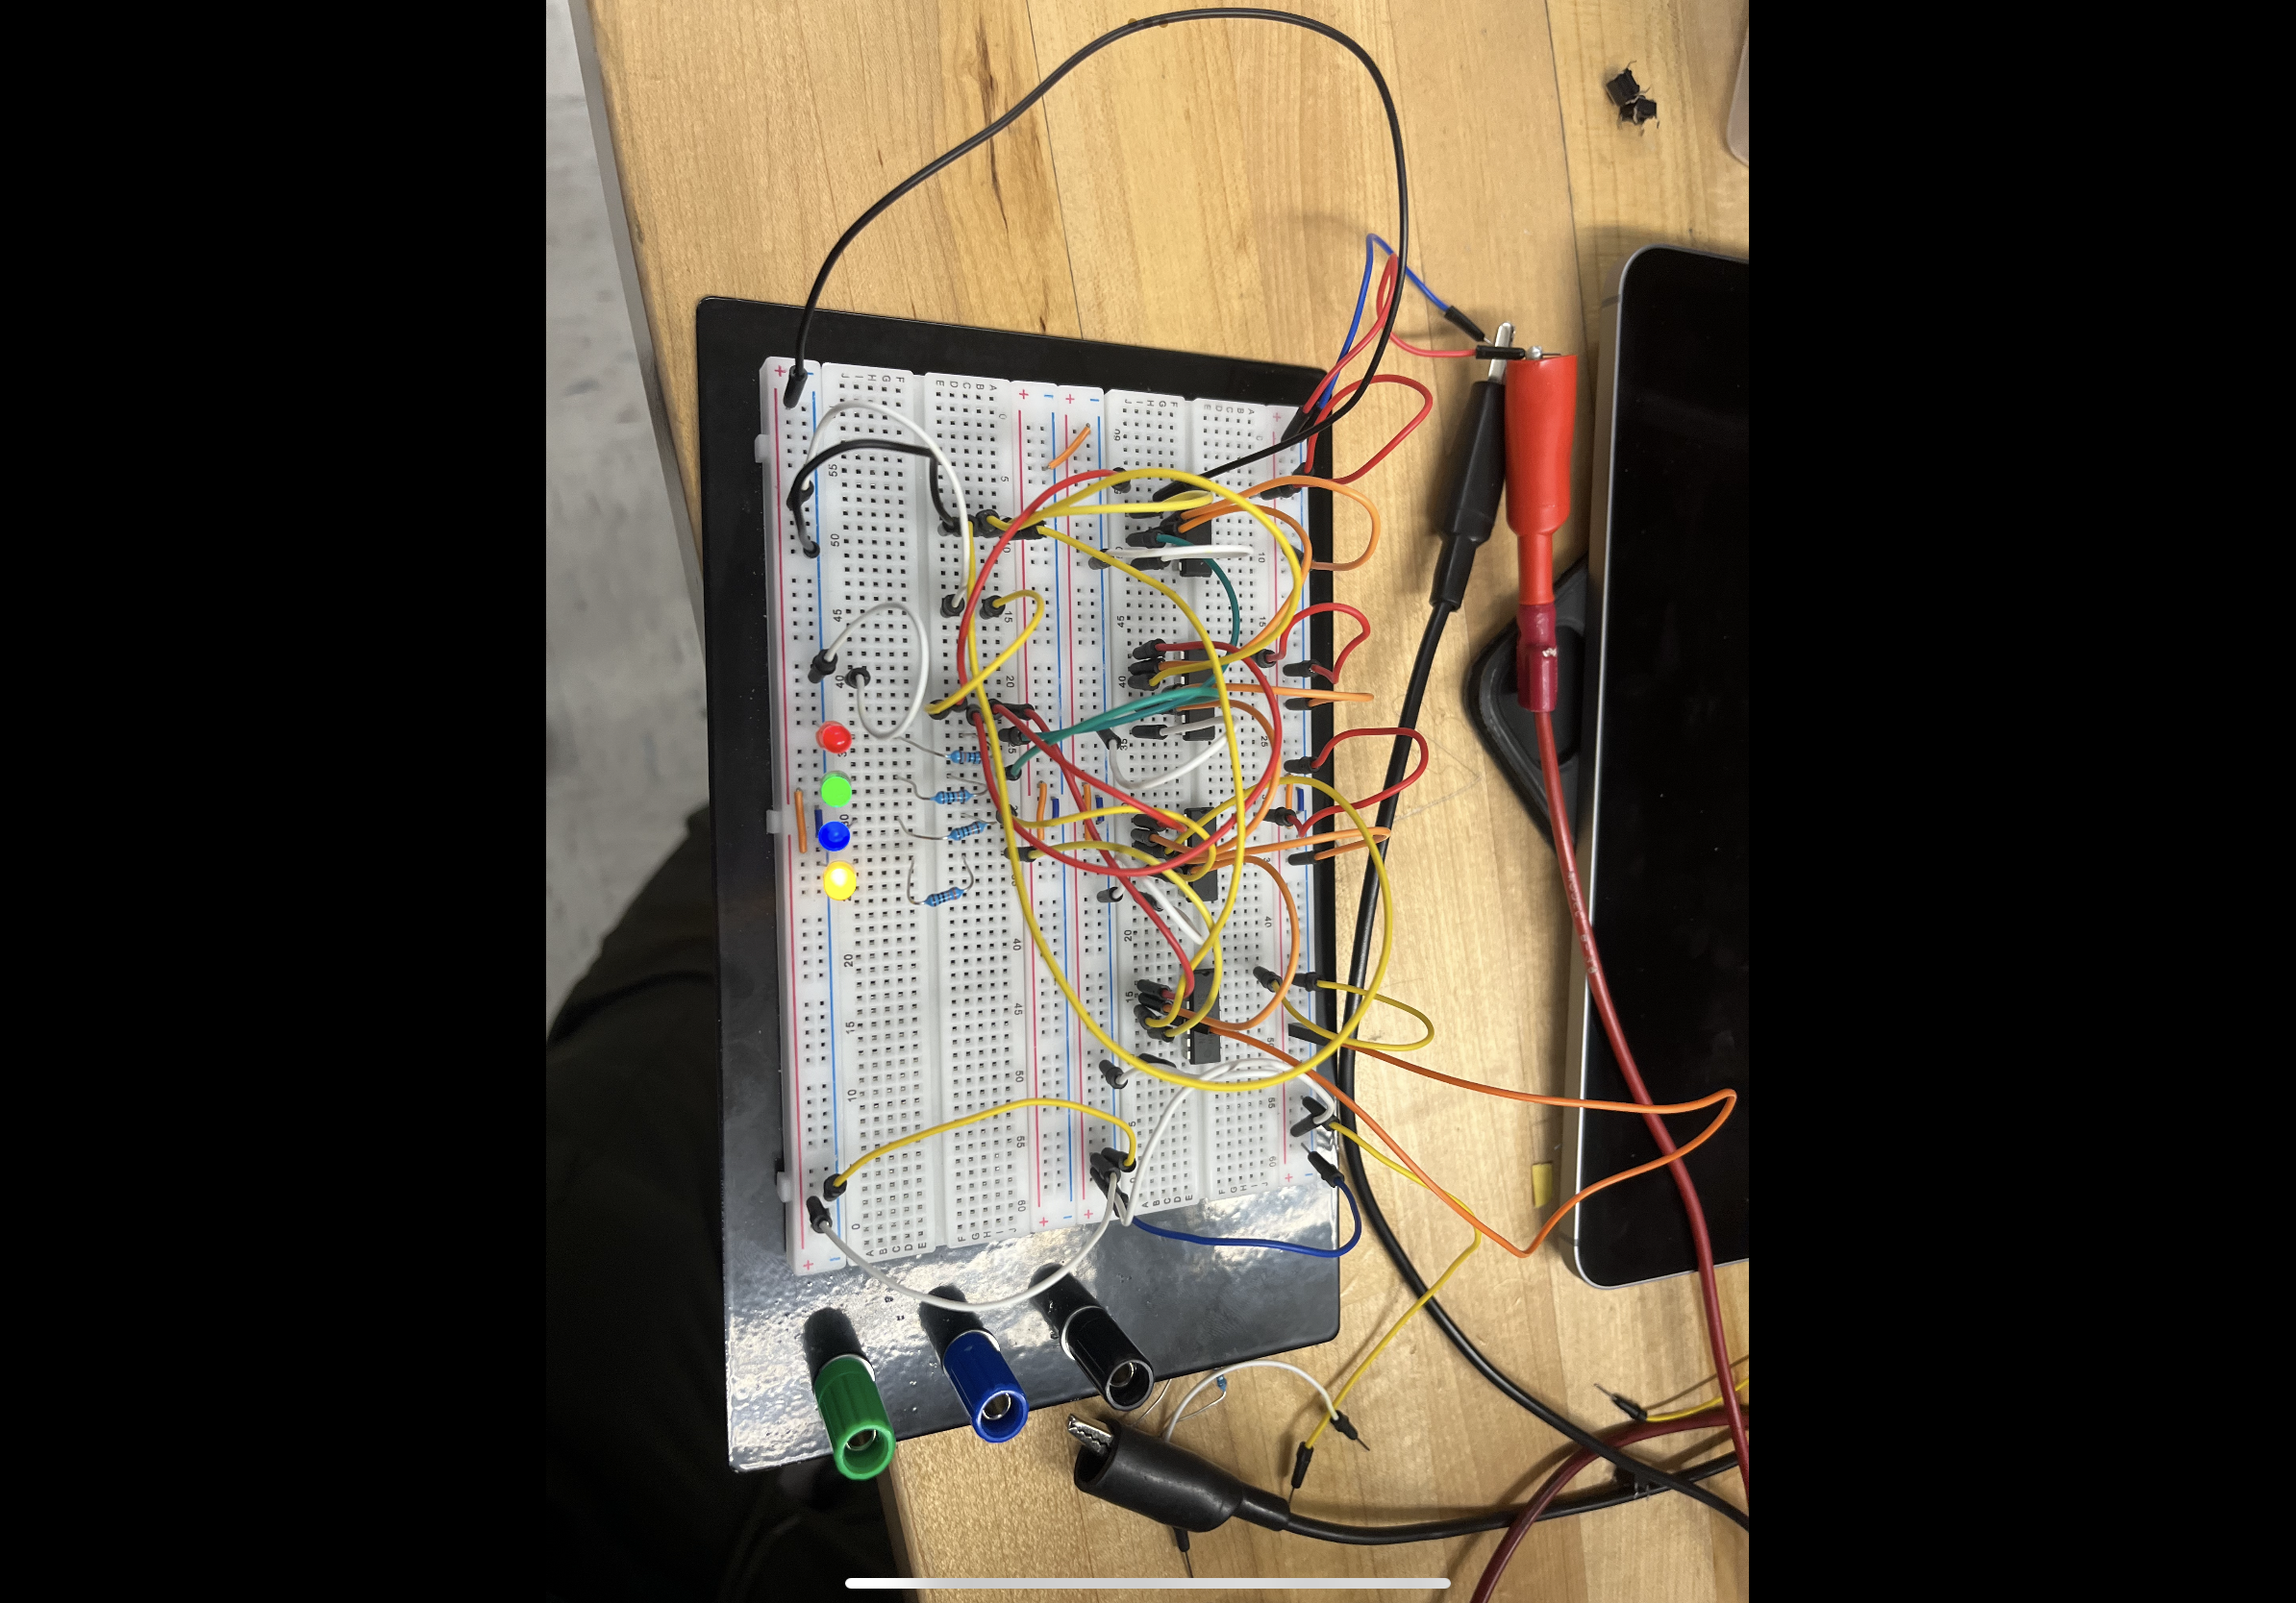

Data Readings

| **Clock** | **LED 1** | **LED 2** | **LED 3** | **LED 4** |
| --- | --- | --- | --- | --- |
| 0 | 0 | 0 | 0 | 0 |
| 1 | 0 | 0 | 0 | 1 |
| 2 | 0 | 0 | 1 | 0 |
| 3 | 0 | 0 | 1 | 1 |
| 4 | 0 | 1 | 0 | 0 |
| 5 | 0 | 1 | 0 | 1 |
| 6 | 0 | 1 | 1 | 0 |
| 7 | 0 | 1 | 1 | 1 |
| 8 | 1 | 0 | 0 | 0 |
| 9 | 1 | 0 | 0 | 1 |
| 10 | 1 | 0 | 1 | 0 |
| 11 | 1 | 0 | 1 | 1 |
| 12 | 1 | 1 | 0 | 0 |
| 13 | 1 | 1 | 0 | 1 |
| 14 | 1 | 1 | 1 | 0 |
| 15 | 1 | 1 | 1 | 1 |

**Discussion**

**1.1 Asynchronous Counters**

In our experiment with asynchronous (ripple) counters, we got a clear view how these sequential logic circuits work and their limitations. By setting up the circuit and observing its behavior, we noticed that the cascading trigger mechanism in asynchronous counters leads to a cumulative propagation delay and despite it being small for each flip-flop, it adds up quickly as more flip-flops are added which ultimately affects the counter’s overall speed and efficiency. The ripple effect where state transitions move through each flip-flops one after another demonstrates why asynchronous counters in general are not great for high speed applications and the measurable delays between state changes were able to be seen with an oscilloscope. This experiment showcases the importance of considering propagation delays when designing digital circuits as although asynchronous counters are simpler and need fewer connections, their speed limitations can be a problem. For applications that need faster and more reliable timing, synchronous counters might be a better choice since they trigger all flip-flops at the same time eliminating the ripple effect.

**1.2 Synchronous Counters**

In our experiment with synchronous counters, we built and checked how a 4-bit synchronous parallel counter using JK flip-flops works. Unlike asynchronous counters where state changes cause delays due to the ripple effect, synchronous counters are much faster because they clock all flip-flops at the same time with a shared clock signal. We checked the J-K inputs with the excitation and transition tables to make sure the counter worked correctly giving us reliable and consistent counting sequences. This experiment demonstrates how important synchronization is by cutting down delays and boosting the efficiency of state changes.

**Conclusions**

Our lab experiments on asynchronous and synchronous counters provided a comprehensive understanding of the fundamental differences, advantages, and limitations of each type. Asynchronous ripple counters were easy to build since each flip-flop’s output connected to the next one’s clock input. However, the ripple effect caused delays, limiting their speed and efficiency, which is not great for high-speed usage. Even with the delays, the simplicity of these counters is valuable where the precise timing is not critical. Synchronous counters however demonstrated better performance by avoiding the delays of the ripple counters. All flip-flops clocked simultaneously with one clock signal making state transitions happen together speeding up counting. Using J-K flip-flops in synchronous counters allowed precise control over state transitions. Our hands-on work with both types of counters emphasized the importance of synchronization in digital electronics and good design for circuit performance. Testing the 4-bit synchronous parallel counter highlighted synchronous design’s benefits, with accurate, simultaneous state changes across flip-flops. Comparing both counters helped us understand the trade-offs in counter design. This lab reinforced our theoretical knowledge and gave us practical insights into counter applications. These experiments helped reinforce what we learned in theory and provided practical insights into designing and using counters.